Print Release
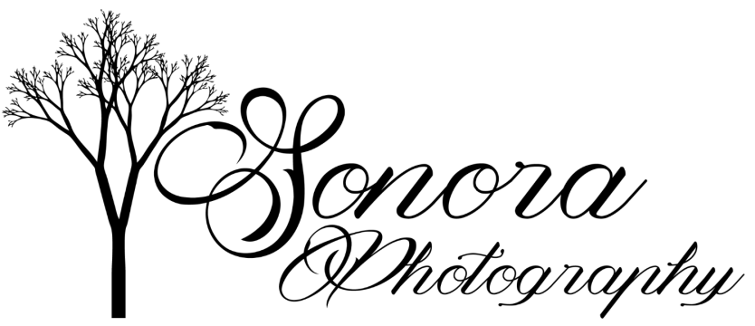

I, Ashleigh Burchett, copyright owner of all Sonora Photography images grant permission for__________________ to make prints of my photography for personal use from their digital prints.
These images are the work of Ashleigh Burchett of Sonora Photography and are protected under copyright law. By accepting these images, you agree to use them for personal enjoyment only. Images may not be altered, or used for publication or profit without written permission.
Per federal copyright law: When sharing online, credit Ashleigh Burchett and Sonora Photography, include photo watermark (logo), and link to http://sonoraphotography.com/
All images are the property of Sonora Photography for advertising use and other purposes.
Sincerely,

Ashleigh Burchett
Owner, Sonora Photography

